(click the image and save)

The logo of the Yau Mathematical Sciences Center (YMSC) is composed of Letter Y and multidimensional Calabi-Yau manifold graphics. Surrounding Letter Y, the multidimensional Calabi-Yau manifold graphics are two-dimensionalized and expanded outward, embodying internationalization, openness and inclusiveness of YMSC. Purple and blue are the two colors of the Logo, the former originates from the University color of Tsinghua symbolizing their strong connection, the latter matches harmoniously with the former representing the serenity and rationality of academic research. The whole logo is concise, solemn, meaningful and identifiable, accurately reflecting the profound culture of Tsinghua University and the academic research focus of YMSC.
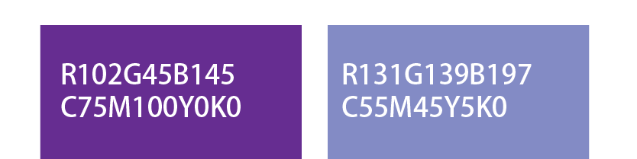
Color Standard Numbers of the Logo

